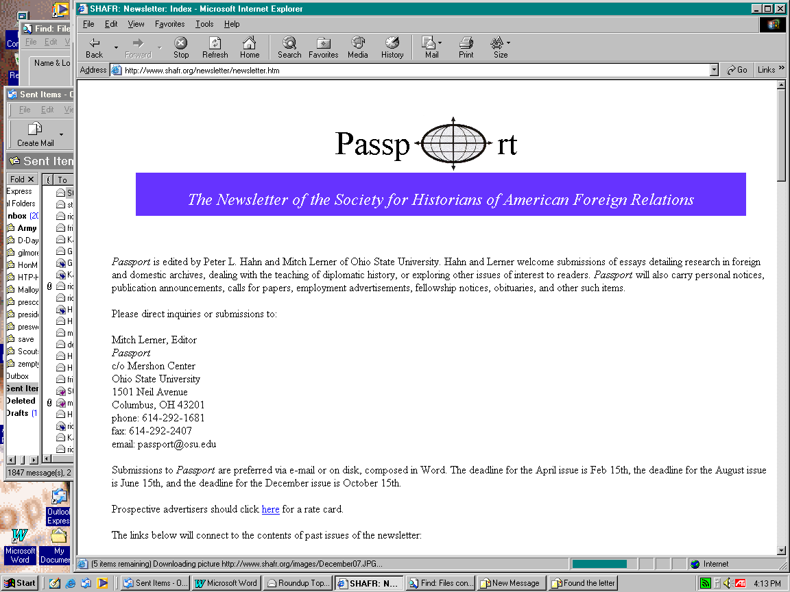
August 2005, vol. 36, no. 2, p. 52
Dear Editor:
J. Samuel Walker is to be commended for tackling a project that has needed to be done for quite a long time in his “Recent Literature on Truman’s Atomic Bomb Decision: A Search for Middle Ground” (Diplomatic History, April 2005) since a considerable amount of new documentation has become available in both the military sphere after the Enola Gay controversy, and in Japan after the death of Emperor Hirohito. I must, however add some small correctives.
My February 2003 Pacific Historical Review article does not depict Herbert Hoover’s well known memorandum warning of 500,000 to 1,000,000 American deaths during an invasion of Japan “as conclusive evidence that Truman knew about and accepted huge casualty projections.” The article’s central point is not simply that the memo was seen by Truman, but that he reacted decisively to it. I used documents I discovered at the Harry S. Truman Presidential Library to demonstrate that the subsequent flurry of memoranda between Truman and his senior wartime advisors -- the Truman-Grew-Hull-Stimson-Vinson exchange -- prompted him to convene the June 18, 1945, meeting at which the invasion of Japan was given final approval. Yet another discovery, by the Hoover Presidential Library’s former senior archivist Dwight Miller, indicates that the casualty estimate likely originated during Hoover's regular briefings by a group of Military Intelligence officers from the Pentagon who Robert H. Ferrell wryly refers to as “a cabal of smart colonels.”
The PHR article is available through the University of California Press at http://caliber.ucpress.net/toc/phr/72/1, and is very briefly summarized in my April-May 2003 American Heritage piece at http://www.americanheritage.com/articles/magazine/ah/2003/2/2003_2_13a.shtml.
Walker also says that “[Giangreco] elaborated his objections [to one of Bernstein’s essays] at length on a web site.” In fact, I sent a draft of my letter intended for publication in the Journal of Military History to a number of scholars in the Society for Military History and SHAFER soliciting their opinions on what should be cut because “its current version is far too long to be printed in the journal (and is somewhat more ‘hot’ than the final product should be).” Much to my surprise, the draft and cover letter soon appeared on an Internet site. [The draft is now available at http://www.waszak.com/giangreco/Rousseau_or_Monboddo.htm] After some discussion with the webmaster, I gave permission to leave it online principally because the draft contained a detailed defense of the work of both Ferrell and Robert P. Newman, as well as some fascinating quotes from Martin Harwit’s An Exhibit Denied: Lobbying the History of the Enola Gay, that there was simply no room for in JMH.
Yes, there were attendees at the 1998 SMH conference who displayed considerable hostility to Bernstein calling him a “charlatan,” a “vampire,” and, several times, a “crackpot.” I said then and later wrote, as Walker correctly quotes from the draft, that this was “overly harsh” and ventured that “he is really just a misguided scholar completely and irretrievably out of his element when discussing things related to the military.” But Walker incorrectly surmises that this is “poorly disguised name calling.” This is hardly “disguised.” It is indeed what was said by some of the attendees. The irony is that in his search for the “middle ground,” Walker overlooked the fact that these comments were made at least partially as criticism of me because of the generous praise I made of Bernstein in the summary of my address at the awards luncheon:

. . . In recent times, the public’s perception of Truman's decision has been influenced by [a] misplaced focus on limited briefing documents produced literally after the invasion ships had already started to sail. I earnestly hope that members of the Society will examine this area more closely because SMH can greatly influence scholarly opinion and public perceptions on this subject and, ultimately, how we as a nation view our history and ourselves.
I would like to thank the awards committee and the members of the Society as well as Larry Bland and Bruce Vandervort who did a splendid job editing the study. I'd also like to thank Dr. Michael DeBakey at Baylor for his continued encouragement and support as well as Fred Schultz at the Naval Institute who patiently allowed me to bend his ear with my random thoughts. And, finally, Barton Bernstein whose early work in this area and encouragement prompted me to examine the subject more thoroughly.
Now, obviously, Bernstein and I disagree on a number of matters and have carried on a vigorous debate in several venues where, subsequent to the awards luncheon, he has in print described my “strained,” “deeply flawed,” “self serving” work as filled with “confusion and intellectual sloppiness,” “dubious conclusions,” and the “misreading/misreporting” of documents, plus referred to me personally as an "amateur historian.” But in all the heat, more than a little light has shown. And objective scholars have taken note of this. In Newman's fine new book, Enola Gay and the Court of History, he writes “Three persons have been of inestimable help in prodding me away from heresies and banalities without end: Barton Bernstein, D. M. Giangreco, and Edward Linenthal. I hope they are not disappointed with my conclusions.”
It is fair to say that there is not likely to ever be consensus on the events surrounding the final days of World War II. All that the participants in this debate can hope for is that scholars will objectively and comprehensively examine their work instead of finding it characterized, as Walker charges, as having “reduced the tone of professional discourse to unprecedentedly low levels.”
D. M. Giangreco
U.S. Army Command and General Staff College
Fort Leavenworth, Kansas

