http://gordsswimlog.blogspot.com/2011/08/tooele-transcript-july-22-1958.html#gpluscomments

TOSHIO IMAI
UNDER CONSTRUCTION, 13APR2007.

SATURDAY, APRIL 14, 2007

Antelope Island to Saltair, July 19, 1958..
Tooele Bulletin, Tuesday, July 22, 1958
Toshio Imai, Barbara Harker Win Great Salt Lake Swim Race
Records Shattered in Choppy Brine
Apparently getting inspiration from his island starting point, Toshio Imai, made like an antelope, Saturday afternoon, to win the Great Salt Lake swimming race from Antelope Island to Saltair in the record-shattering time of one hour, 45 minutes, and 23 seconds.
Fast developing into one of the Intermountain West's greatest swimmers, the 17-year-old Imai, who represented Tooele Swim Club broke the two hours, nine minutes, 53 seconds record set last year for the five-mile 100-yard course, by his former teammate, Jerry Chadwick, who did not compete, this year.
Over-shadowed by the record race of Imai's, but just as remarkable, was the competition provided by the three girls who entered the race. A penalty of 15 minutes was given the girls – Barbara Harker, 14, and Martha Ann Welch, 11 of Tooele and Gerry Hendricks, 15, of Deseret Gym, because they started the race approximately one-half mile from the shores of Antelope Island where the boys started.
Even with the 15-minute penalty, Harker turned in the time of two hours, 17 minutes and 18 seconds to win the girls' division. She was followed by Hendricks, with a corrected time of two hours, 24 minutes flat. Little Martha Ann Welch proved that she had what it takes by swimming the entire race and finishing with a time of two hours, 34 minutes.
John Bryan of Tooele finished second to Imai, and Art Magill of Magna finished third, just 131 seconds behind Bryan. Both broke Chadwick's record, with Bryan clocking 2:03:07 and Magill 2:03:20.
Revel George, of Tooele, who originally went along just for the ride, decided at the last minute to swim the race, and finished fourth in the men's division, clocked at a time of two hours, 28 minutes.
Imai literally sprinted the whole distance, doing a modified version of the Australian crawl, and only stopped twice, for water, and an eye washout. He also was the only one who didn't wear goggles.
Since the Great Salt Lake race was revived in 1956, Tooele swimmers have completely dominated the event. Chadwick won the event in 1956 and 1957, with Imai second both of those years. Bryan, who finished second this year, was third last year.
The contestants, officials, and other members of the swimming party were transported to the island from the Salt Lake boat harbor, and followed the race in five boats. Three were furnished by Sea Scout troops 550, 398 and 236, skippered by Don Kleinman, B. W. Dille and Jim Jones.
Also furnishing boats were E. C. Kimball, whose craft was skippered by Jack Reynolds of Salt Lake City and Pete Ecker, president of the Intermountain AAU, who piloted his own boat.
After the race, contestants and officials were feted at an awards dinner at Saltair, where Mr. Ecker presented first and second place boys and first and second place girls with tropheys.
The Great Salt Lake race is one of the most unique and difficult swimming races held anywhere in the world. Because of the 27 per cent salt content, it is almost impossible to use the feet – so modified swimming strokes have to be used. The salt also causes severe burning to the eyes, nose, and throat, making the water that much more difficult to swim thru.
Another unique aspect of the race is that contestants are actually dried out by swimming in the brine, and need large quantities of fresh water.
Because of the extreme difficulties encountered. No woman has ever competed in the race until Martha Ann Welch, daughter of Mr. and Mrs. Frank B. Welch, and Barbara Harker, daughter of Mr. and Mrs. Kenneth Harker decided to brave the course, this year. They were joined by Gerry Hendrickson, daughter of Mr. and Mrs. Bud C. Hendrickson of Granger.
Martha, who is 11 years old; Barbara, 14, and Gerry, 15, all finished the race in good time – a fete that a lot of older more experiences men swimmers haven't been able to accomplish.
Imai was recently awarded a scholarship to Michigan state college, where he will join his former teammate and former record-holder, Jerry Chadwick, on the Michigan State swimming team.
The race was under the auspices of the Intermountain AAU and Saltair Co., and was run off as one of Salt Lake City's Days of '57 events.
The race was started by co-chairman Leigh Pratt on Antelope Island, at 2:51 p.m. Pratt and the four men contestants had to wade into the short about one-half mile because of shallow water, and then the first part of the race was by foot out to the deeper water.
Co-chairman Pratt of Tooele and Mel Denhalter of Salt Lake, both Intermountain AAU officials, reported that a move was underfoot to hold next year's race in the early morning, to provide calmer water and cooler weather. This year's event was held in choppy water, with a brisk breeze.

Tooele Transcript - July 22, 1958
I found this page a while back about a race in 1958 that was documented in the Tooele Transcript. I got a hold of Missy Bird, Copy Editor and Sports Writer for Tooele Transcript and she found the article for me, scanned it and sent it to me. Very cool stuff! On a personal note, I went and saw the Doc today. I've got walking pnemonia. Taking three days of antibiotics and I should be pretty close to normal. Can't wait. I feel like I've been ran over by a car.
Here's the article:
The Tooele Bulletin - Tooele Utah Tuesday, July 22, 1958
Toshio Imai, Barbara Harker Win Great Salt Lake Swim Race Records Shattered in Choppy Brine
Apparently getting inspiration from his island starting point, Toshio Imai, made like an antelope, Saturday afternoon, to win the Great Salt Lake swimming race from Antelope Island to Saltair in the record-shattering time of one hour, 45 minutes, and 23 seconds.
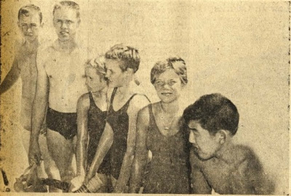
GREASED-UP AND READY TO GO - Seven Swimmers entered the Great Salt
Lake Antelope Island to Saltair race, Saturday, and all seven completed
the race. Shown above, getting ready to leave the boat and begin the race
are L to R – Art Magill, Magna; John Bryan, Tooele; Martha Ann Welch, Tooele;
Barbara Harker, Tooele; Gerry Hendrickson, Deseret Gym and Toshio Imai,
Tooele. Revell George of Tooele decided at the last minute to enter the race,
as he originally went along just for the ride.
Fast developing into one of the Intermountain West's greatest swimmers, the 17-year-old Imai, who represented Tooele Swim Club broke the two hours, nine minutes, 53 seconds record set last year for the five-mile 100-yard course, by his former teammate, Jerry Chadwick, who did not compete, this year.
Over-shadowed by the record race of Imai's, but just as remarkable, was the competition provided by the three girls who entered the race. A penalty of 15 minutes was given the girls – Barbara Harker, 14, and Martha Ann Welch, 11 of Tooele and Gerry Hendricks, 15, of Deseret Gym, because they started the race approximately one-half mile from the shores of Antelope Island where the boys started.
Even with the 15-minute penalty, Harker turned in the time of two hours, 17 minutes and 18 seconds to win the girls' division. She was followed by Hendricks, with a corrected time of two hours, 24 minutes flat. Little Martha Ann Welch proved that she had what it takes by swimming the entire race and finishing with a time of two hours, 34 minutes.
John Bryan of Tooele finished second to Imai, and Art Magill of Magna finished third, just 131 seconds behind Bryan. Both broke Chadwick's record, with Bryan clocking 2:03:07 and Magill 2:03:20.
Revel George, of Tooele, who originally went along just for the ride, decided at the last minute to swim the race, and finished fourth in the men's division, clocked at a time of two hours, 28 minutes.
Imai literally sprinted the whole distance, doing a modified version of the Australian crawl, and only stopped twice, for water, and an eye washout. He also was the only one who didn't wear goggles.
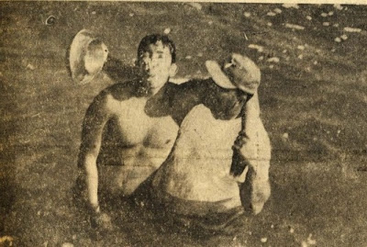
DIZZY AND ALMOST OUT ON HIS FEET, Toshio Imai is helped at the end of the race by his Coach, Leigh Pratt, who helpfully splashes fresh water into his face to wash the crusted salt off.
Since the Great Salt Lake race was revived in 1956, Tooele swimmers have completely dominated the event. Chadwick won the event in 1956 and 1957, with Imai second both of those years. Bryan, who finished second this year, was third last year.
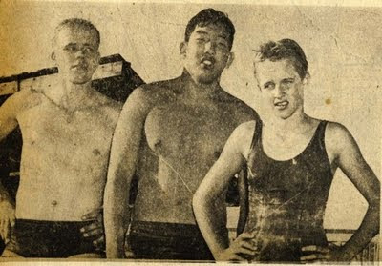
SWIMMERS FROM TOOELE dominated the Great Salt Lake Swim, Saturday, L to R – John Bryan finished second in the men's division, Toshio Imai finished first in record time, and Barbara Harker finished first in the girls' division.
The contestants, officials, and other members of the swimming party were transported to the island from the Salt Lake boat harbor, and followed the race in five boats. Three were furnished by Sea Scout troops 550, 398 and 236, skippered by Don Kleinman, B. W. Dille and Jim Jones.
Also furnishing boats were E. C. Kimball, whose craft was skippered by Jack Reynolds of Salt Lake City and Pete Ecker, president of the Intermountain AAU, who piloted his own boat. After the race, contestants and officials were feted at an awards dinner at Saltair, where Mr. Ecker presented first and second place boys and first and second place girls with trophies.
The Great Salt Lake race is one of the most unique and difficult swimming races held anywhere in the world. Because of the 27 per cent salt content, it is almost impossible to use the feet – so modified swimming strokes have to be used. The salt also causes severe burning to the eyes, nose, and throat, making the water that much more difficult to swim thru.
Another unique aspect of the race is that contestants are actually dried out by swimming in the brine, and need large quantities of fresh water.
Because of the extreme difficulties encountered. No woman has ever competed in the race until Martha Ann Welch, daughter of Mr. and Mrs. Frank B. Welch, and Barbara Harker, daughter of Mr. and Mrs. Kenneth Harker decided to brave the course, this year. They were joined by Gerry Hendrickson, daughter of Mr. and Mrs. Bud C. Hendrickson of Granger.
Martha, who is 11 years old; Barbara, 14, and Gerry, 15, all finished the race in good time – a fete that a lot of older more experiences men swimmers haven't been able to accomplish.
Imai was recently awarded a scholarship to Michigan state college, where he will join his former teammate and former record-holder, Jerry Chadwick, on the Michigan State swimming team.
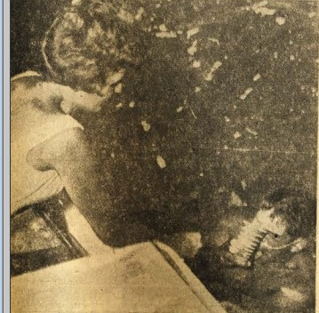
PETITE MARILYN KIMBALL hands a cup of cool water to Toshio Imai at one of the two stops he made during a record-setting swim on Great Salt Lake, Saturday.
The race was under the auspices of the Intermountain AAU and Saltair Co., and was run off as one of Salt Lake City's Days of '57 events.
The race was started by co-chairman Leigh Pratt on Antelope Island, at 2:51 p.m. Pratt and the four men contestants had to wade into the short about one-half mile because of shallow water, and then the first part of the race was by foot out to the deeper water.
Co-chairman Pratt of Tooele and Mel Denhalter of Salt Lake, both Intermountain AAU officials, reported that a move was underfoot to hold next year's race in the early morning, to provide calmer water and cooler weather. This year's event was held in choppy water, with a brisk breeze.
I was hoping to get a hold of Mr Imao, but unfortunately he passed away last year. Here is his obituary.
Swam by Gordon Gridley a little before 16:57

POSTED BY HAKUJINSHOGI AT 10:22 AM

2 COMMENTS:
Etsuko said...
Toshio san, anata wa watashi no hero desu. I can't believe you swam from Antelope Island to Saltair in 1 hour and 45 minutes! Without goggles! I just swam one mile in the Great Salt Lake yesterday and I thought that was hard. I am hoping that more Japanese swimmers will come to experience the world's unique body of water.
JUNE 10, 2012 AT 6:38 PM
Etsuko said...
Toshio san, anata wa watashi no hero desu. I can't believe you swam from Antelope Island to Saltair in 1 hour and 45 minutes! Without goggles! I just swam one mile in the Great Salt Lake yesterday and I thought that was hard. I am hoping that more Japanese swimmers will come to experience the world's unique body of water.
JUNE 10, 2012 AT 6:39 PM
Post a Comment
Newer PostHome
Subscribe to: Post Comments (Atom)

BLOG ARCHIVE
- ► 2009 (2)
- ▼ 2007 (1)
  - ▼ April (1)
    - Antelope Island to Saltair, July 19, 1958..

ABOUT ME
HAKUJINSHOGI
VIEW MY COMPLETE PROFILE

Stream

Etsuko
3 years ago

5 miles in 1 hour 45 minutes? Waves must have been pushing him but still that is amazing. And he did it without goggles. Ouch! I shared the story of Imai with my Japanese friends and one of them said that Imai must have been a Kappa, a legendary half human half turtle creature that lives in the lakes of Japan.
TOOELE TRANSCRIPT BULLETIN April 27, 2010 SERVING TOOELE CTY SINCE 1894 VOL. 116 NO. 95 50¢
Toshio Imai Lansing, MI Age 70, born November 22, 1939 in San Francisco, Calif. A graduate of Tooele High School, class of 1957 and ’58, Toshio was a state champion swimmer and set the record for the race from Antelope Island to Saltair. He attended Michigan State University and retired as an employee of MSU. He died peacefully in Lansing, Mich., at age 70 after an illness of several months. Toshio is survived by his wife of 28 years, Sue Eareckson; sisters Carole of Reedley, Calif. and Ellyn Mukai (Gerrold) of Reston, Va.; brothers Mark and Ren (Janet Habegger) of Reedley, Calif.; several nieces and nephews, and several great-nieces and nephews. He was a loving husband and a devoted friend. There will be no services. Contributions may be made to the American Heart Association, Memorials and Tributes Lockbox, 3816 Paysphere Circle, Chicago, IL 60674. Online condolences may be made at www.gorslineruncimanlansing.com

